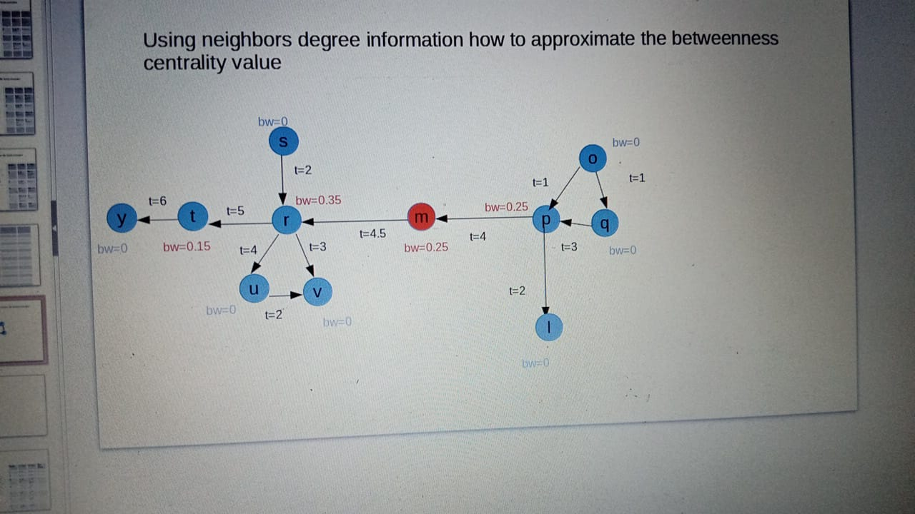

Temporal betweenness values

[ ‘m’:0.00824176,’o’: 0, ‘p’: 0.00824176, ‘q’: 0, ‘r’: 0.01098901, ‘s’: 0, ‘t’: 0.00549451, ‘u’: 0, ‘v’:0, ’l’:0, ‘y’:0]